Control Room Operating Procedure
Weyland Control Centre, Edinburgh (24/7)
David Chen · 24 August 2026 · OPS-PRO-0001

1. Role of the control centre
The Weyland Control Centre in Edinburgh monitors and operates all 13 operating assets (1,100 MW) in the UK, Germany and Denmark around the clock. It is the single point of contact for grid operators, O&M contractors, landowners and emergency services outside office hours. From 2027 it will also take over remote operation of Harrow Bay Offshore Wind.
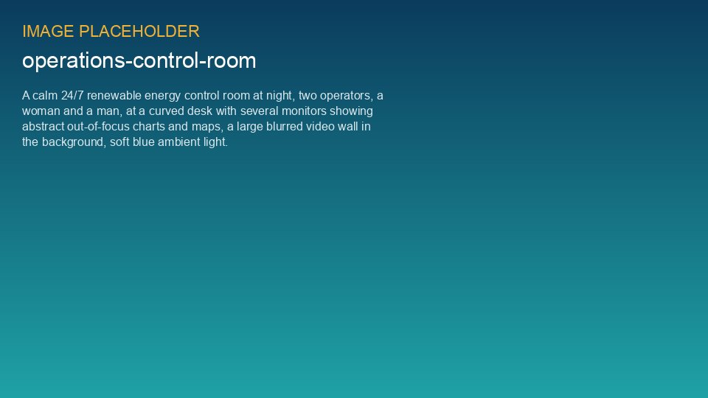
Weyland Control Centre, Edinburgh

2. Staffing and shifts
Item | Rule
Shift pattern | 12-hour shifts, day 07:00–19:00, night 19:00–07:00; 4 crews
Minimum staffing | 2 operators per shift; 1 must hold the Senior Authorised Person (HV) qualification
Supervisor on call | Control room supervisor, reachable within 15 minutes
Asset manager on call | Weekly rota (David Chen, Ben Okoye, Patrick Doyle, Sara Lindgren)
Languages | English; German-speaking operator on every shift for TSO calls in Germany

3. Core tasks
- Monitor SCADA alarms of all assets and respond according to the Alarm Response Matrix.
- Carry out remote resets where allowed (never after safety-chain, fire, bearing temperature or ice alarms).
- Execute grid operator instructions: setpoints, curtailment (UK constraint instructions, German Redispatch 2.0, Danish TSO).
- Coordinate access to sites: log technicians in and out, check working alone calls every 60 minutes.
- Manage emergency calls and initiate the emergency response plan of the site.
- Keep the shift log and carry out a structured handover at every shift change.

4. Shift handover
Handover takes 20 minutes and is done face to face at the operator desk. The outgoing operator updates the shift log (Markdown file per shift in Control Room/Shift Handover Logs) before handover. The incoming operator confirms the log and the open items by adding their name.
Handover item | Content
Safety | People on site, open permits, working alone, weather warnings
Assets | Turbines/inverters stopped and why, open alarms, curtailment in force
Grid | Instructions received, planned outages, setpoints
Open actions | Callbacks, contractor dispatches, escalations
Systems | SCADA, telephony, IT issues

5. Escalation
Situation | Escalate to | Within
Injury or emergency on site | 999/112 first, then HSE Manager and asset manager on call | immediately
Fire alarm at a substation or turbine | Fire brigade, then site manager and asset manager | immediately
Major component alarm (bearing temperature, gearbox debris) | Asset manager on call | 30 min
Grid instruction that cannot be followed | TSO control room + supervisor | immediately
Cyber security event (unknown login, malware alert) | IT & Security on-call (Northlight IT Services) + Katarzyna Nowak | 15 min
Media or public enquiry | Marketing & Communications on call | 60 min

6. Remote reset rules
Never reset a turbine remotely after: safety chain, fire, smoke, bearing temperature high, gearbox debris, ice detection or overspeed alarms. These require an inspection on site. This rule was confirmed after KR-INC-2026-003, where the night operator correctly did not reset T-07.

7. Systems
SCADA access is via the Weyland jump host with multi-factor authentication. Each asset has an independent local SCADA; the control centre has read/write access to all of them. If the Edinburgh site is lost, the backup workstation at the Hamburg HQ can take over within 60 minutes (tested in March 2026).

